Psychology transition project
What is psychology?
Watch this link to start - https://www.youtube.com/watch?v=vo4pMVb0R6M
Psychology is all about explaining human and animal behaviour. Within Psychology we explore a range of possible reasons as to why people act the way they do.
There are numerous psychological theories, all of which take a slightly different approach to explaining behaviour.
Your task will be to use these theories to explain the behaviour of an infamous criminal of your choice.
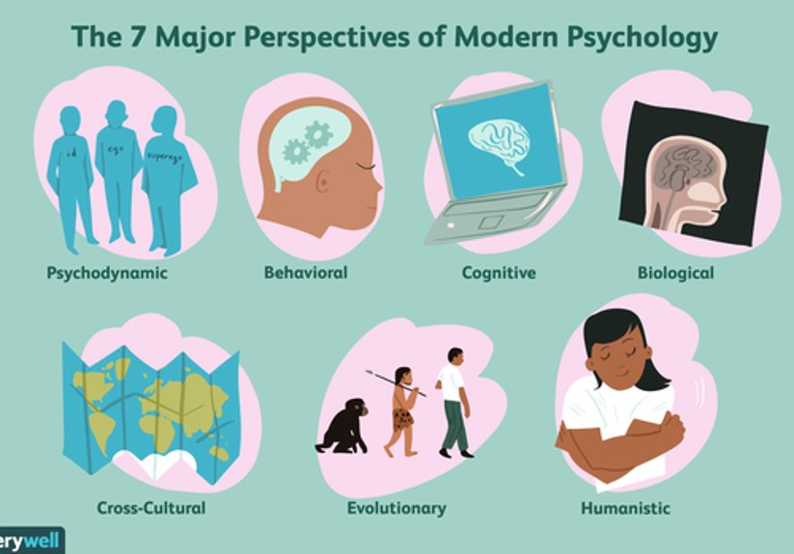
The project
- Find an example from the media (past or present) of someone who has committed a crime and been found guilty of it.
- Create a fact file about their background, the crime they committed and the consequences, and what sentence they were given.
- Give at least 3 psychological reasons as to why they have committed the crime: E.g. Biological, behavioural and cognitive each explanation needs to be supported with at least one piece of research - https://scholar.google.com/
- Write a conclusion stating which explanation you believe to be the most valid and why. Your conclusion could also include a suggestion on what needs to be done to stop future crimes like this.
- Make a suggestion about what, if any, methods of modifying behaviour the perpetrator could/should be given to prevent re offending (treatment).
Power point overview: https://academiestrust-my.sharepoint.com/:p:/g/personal/annette_muckett_kingsthorpecollege_org_uk/EWbPfLV4pSJJlrU6DqCpgrwBn6Ni_D_cthpE-CRs5ULMKA?e=XCo7q4

